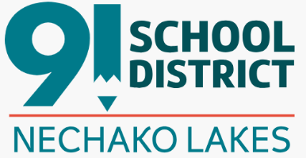
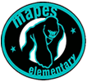
School Code of Conduct for Students
Each student* in the Nechako Lakes School District is required to adhere to the District Code of Conduct for Students and the Mapes Elementary Codes of Conduct.

It is expected that students* will:

Respect the rights of others within the school community including peers, staff, parents, and guests.

Work to the best of their abilities with the goal of always improving.

Follow the directions of school staff. Speak to the Principal if you have concerns or questions about directions from staff.

Respect the school building, equipment, and the property, including property of others. Students (or their parents) may be held financially responsible for repairs or replacement of property purposely damaged.

Respect the diversity of our school community and the BC Human Rights Code which prevents discrimination based on race, national or ethnic origin, colour, religion, sex, age, mental or physical disability, gender identification/expression, sexual orientation or sexual orientation as perceived by others.

Conduct themselves in a safe and responsible manner at all times.

Not threaten, harass, bully, intimidate or assault, in any way, any person within the school community. This includes cyber bullying.

Not be in possession of any object that, in the opinion of the Principal or Vice Principal, is potentially dangerous. This includes any weapons, legal or illegal, including replicas/imitations.

Not be in possession or under the influence of drugs, alcohol, or other banned items.

Not be in possession of or use tobacco, drugs or vape type products in school buildings, on school trips or on school property.

Follow specific rules for travelling on school buses including remaining in your seat and keeping the aisle clear while the bus is moving or preparing to move, keeping your hands and body to yourself, using polite language and a low-volume voice when speaking, following any rules about foods and drinks set by the driver or responsible adult, and disposing of garbage appropriately.

The Board restricts the use of personal digital devices at school for the purpose of promoting online safety and focused learning environments.

Elementary School Students
For students in elementary schools, personal digital devices must be powered off and safely stored away during the entire school day, from the time the student arrives on school grounds until they leave school grounds. This extends to instructional time, while off school property (e.g. field trip).
Students in elementary schools may only use personal digital devices during the school day for instructional purposes and to promote digital literacy, and only with the permission and direct supervision of a teacher or other staff member.

All Students K-12
Any use of personal digital device during instructional hours will be appropriate to a student’s age and developmental stage.
All students are responsible for safe storage of any personal digital device(s) brought to school.
Exemptions for Individual Students
Individual students (and their caregivers) at any grade level with documented and verified needs, such as accessibility, medical, health, or learning needs may work with the School Based Team to develop an exemption plan that requires the use of a personal digital device for full inclusion.
Use of a personal digital device during the school day or instructional hours will be considered in matters of equity, such as a lack of internet access at home.
Final approval of any exemption must be given by the School Principal, and the approved plan will be shared as necessary and appropriate with staff members.
*Special considerations apply to students who are unable to comply with the School Code of Conduct due to having a disability/condition of an intellectual, physical, medical, sensory, emotional, or behavioural nature.

